**SPSS Practical 9:**

**Part A**

A professor is interested to know how different teaching methods affected students’ knowledge. Three different methods (punishment, indifferent, and reward) have been applied on three different groups of students and their exam scores are recorded as follow:

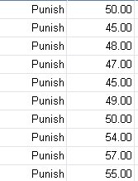 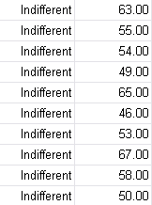 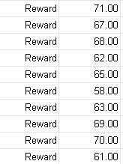

Carry out a One-way Independent ANOVA to test the hypotheses that:

1. reward results in better exam scores than either punishment or indifference
2. indifference will lead to significantly better exam scores than punishment

**Part B**

A medical doctor would like to know the effect of different drugs to a disease. The pain score for each drug is recorded as follows:



Carry out a One-way Independent ANOVA to test the effect of different drugs.